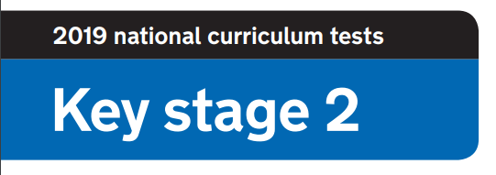

**2020 National Curriculum Tests**

**KS2 Lockdown SATs**

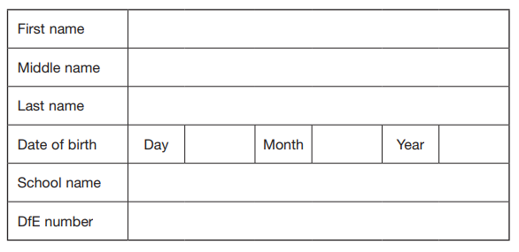

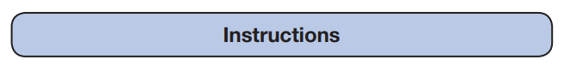

**Questions and Answers**

Work as quickly and as carefully as you can.

If you cannot do a question, go on to the next one. You can come back to it later, if you have time.

If you finish before the end, go back and check your work.

Paper 9: Reading

**Name the books using the emoji clue**

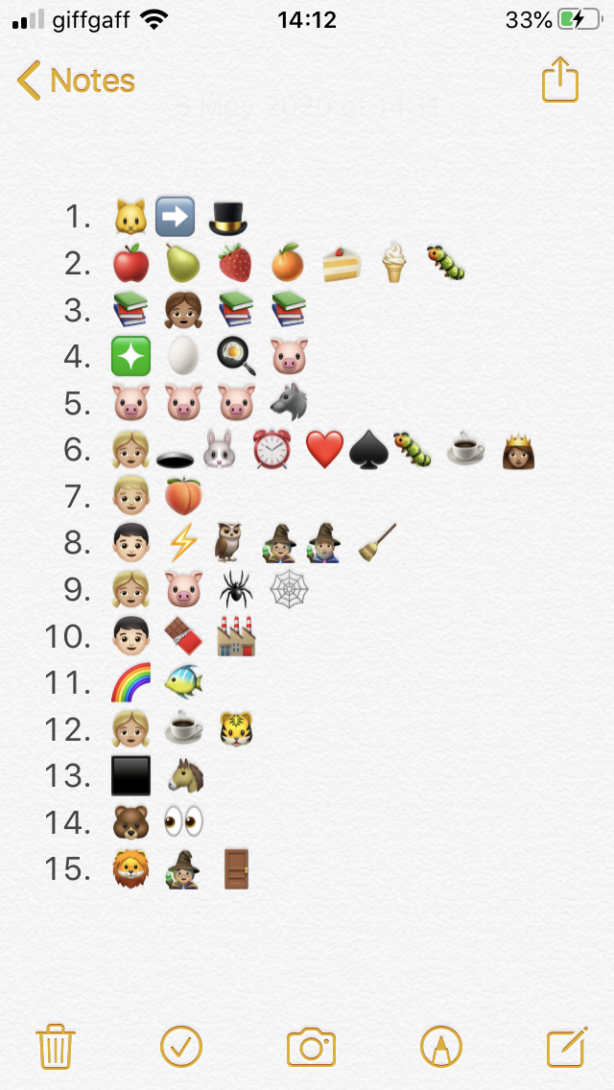

**1 mark**

**1 mark**

**1 mark**

**1 mark**

**1 mark**

**1 mark**

**1 mark**

**1 mark**

**1 mark**

**1 mark**

**1 mark**

**1 mark**

**1 mark**

**1 mark**

**1 mark**

Paper 10: Secondary School

**Visit your secondary school’s website and answer the following questions.**

1. What is your secondary school’s website?

**1 mark**

1. What is the motto or key values?

**1 mark**

1. What is the principal/ head teacher’s name?

**1 mark**

1. Are there houses or teams in your new school? If so, what are they called?

**1 mark**

1. Name 3 exciting facts.

**3 marks**

1. Draw the school logo.

**1 mark**

1. What is the school uniform?

**2 marks**

1. Do they have a social media page to share information?

**1 mark**

1. Find a quote from a pupil at your secondary school. What do they think of the school?

**1 mark**

1. What sports facilities does your secondary school have?

**1 mark**