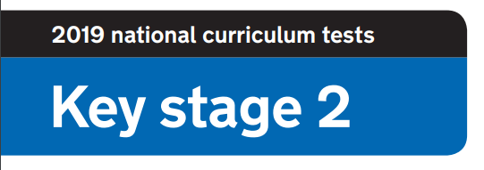

**2020 National Curriculum Tests**

**KS2 Lockdown SATs**

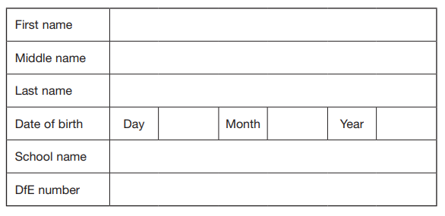



**Questions and Answers**

Work as quickly and as carefully as you can.

If you cannot do a question, go on to the next one. You can come back to it later, if you have time.

If you finish before the end, go back and check your work.

Paper 3: Where’s Wally?

**Timed paper. You will need a stopwatch.**

**Time how many seconds it takes to find Wally.**



Paper 4: How well do you know the teachers?

**Match the boxes to make the sentences true**

**1 mark for each correct answer**

Played basketball for Great Britain

Is kept busy with her newborn baby

grew up on a farm

Often get mistaken for a Year 6 pupil

Will often be seen swivelling in his chair

Likes wearing anything with sparkles

Is an ex-Liverpool football player

is Aston Villa’s biggest fan

Is a huge Harry Potter fan

Mrs Glover

Mrs Routledge

Mrs Moazzam

Miss Baker

Mrs Chandler

Miss Rodgers

Miss Kozub

Mr Starling

Mrs Cox

Mr Hancock

Mr Burbidge

Miss Pope

Miss Wensley

If they weren’t a teacher, this person would be an artist

will eat all the cakes in the staff room

Is a fantastic knitter