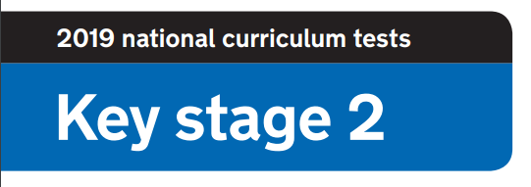

**2020 National Curriculum Tests**

**KS2 Lockdown SATs**

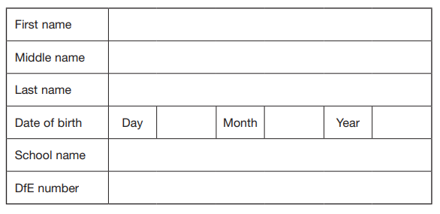

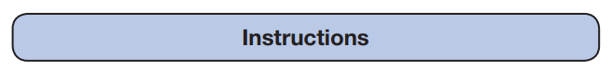

**Questions and Answers**

Work as quickly and as carefully as you can.

If you cannot do a question, go on to the next one. You can come back to it later, if you have time.

If you finish before the end, go back and check your work.

Paper 1: How well do you know your school?

1. What picture is on our school logo?

**1 mark**

1. What are our six school values?

**1 mark**

1. Which two adults can be found working away in the cabin?

**2 marks**

1. Around main school were many adults and children’s different aspirations for the year. Can you remember what Mrs Beardah’s aspiration was?

**1 mark**

1. By the hall is the Walter Halls ‘Wall of Fame’ display. Can you name one of the people on the display and why they are there?

**2 marks**

1. Which two teachers have classrooms on the bottom floor of the new block?

**1 mark**

1. How many tyres have been installed on the bottom playground?

**1 mark**

1. As you walk into school into the office, you have to go through two sets of doors. What colours are those doors?

**2 marks**

1. Where would I find the year one classrooms?
2. **mark**
3. Can you name two of the different foundation classes that are named after animals?
4. **marks**

Paper 2: How well do you know chocolate?

**Can you name the chocolate bars below?**

**You will be awarded 1 mark for each correct answer.**

|  |  |  |  |
| --- | --- | --- | --- |
|  |  |  |  |
|  |  |  |  |
|  |  |  |  |
|  |  |  |  |
|  |  |  |  |
|  |  |  |  |
|  |  |  |  |
|  |  |  |  |