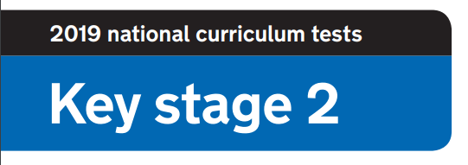
2020 National Curriculum Tests

KS2 Lockdown SATs

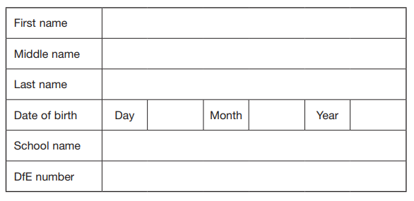

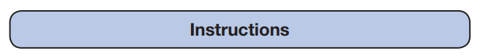

Questions and Answers
Work as quickly and as carefully as you can.
If you cannot do a question, go on to the next one. You can come back to it later, if you have time.
If you finish before the end, go back and check your work.

Paper 5: Scavenger Hunt

Timed paper. You will need a stopwatch.
Starting in the room of your choice, ask a member of your household to time how long it takes to find the objects below. You can find the items in any order. Submit your time and if possible a photograph of the objects found.

FIND THE FOLLOWING OBJECTS:

- An unused toilet roll

- An item of clothing that is the colour you would get if you mixed blue and yellow together

- An item of clothing that has at least 4 buttons on

- A pen, pencil or crayon that is the top colour of a rainbow

- The word ‘SCHOOL’ - look in a book, magazine or newspaper

- Your school jumper

- A tea spoon

- A school photograph of yourself

- Something that will hold everything you’ve found

Paper 6: Spelling Test

What word do you think would fit best in these gaps. Remember: they must be spelt correctly!
I wore a bright pink hat on my _______________.
You must pay ______________ in class.
Due to _______________ changes, ICT club starts at 8am.
There are 2 ______________ mornings for this club.
The green light will __________________the whole room.
I will ____________________ get all my spellings correct.
The accident on the M25 was_______________ a long tailback.
I walked _______________to school along Woodborough Road.
Listening _________________ will help us pass our tests.
Constant talking can be a _____________________.
The house was set in beautiful _____________________.
My cousin is ___________________ twins.
The broken chair was extremely _______________________.
The maths test was very _________________.
I chose a blue and green ________________ as my background.
The documentary about whales was ______________________.
My _______________ and I went to the cinema last night.
The price of petrol will ______________ from station to station.
It is ___________________ to feel nervous before a test.
Most ___________________, you should always get an early night before a test.

