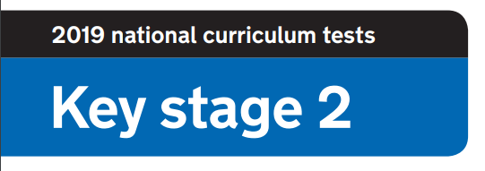
2020 National Curriculum Tests

KS2 Lockdown SATs

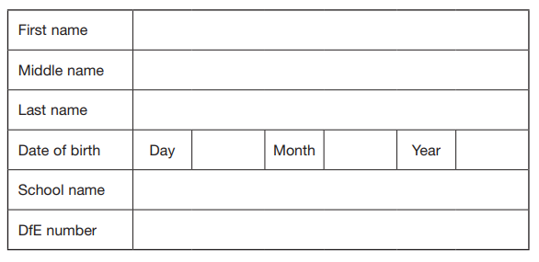

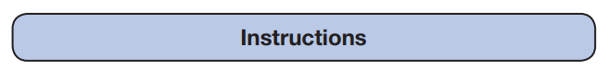

Questions and Answers
Work as quickly and as carefully as you can.
If you cannot do a question, go on to the next one. You can come back to it later, if you have time.
If you finish before the end, go back and check your work.

Paper 7: Art

There
‘Everyday object’ art challenge. Select an object to include in a drawing. Your drawing will be assessed by a panel of adjudicators and given a score out of 5 for each area: creativity, artistic style and humour!

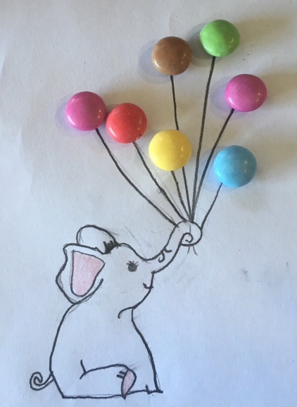
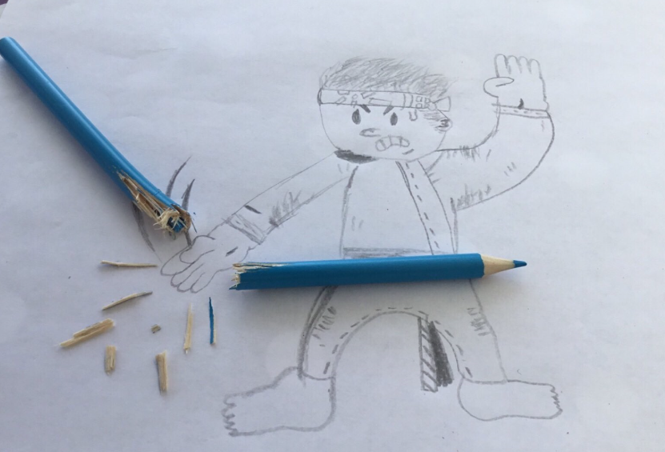
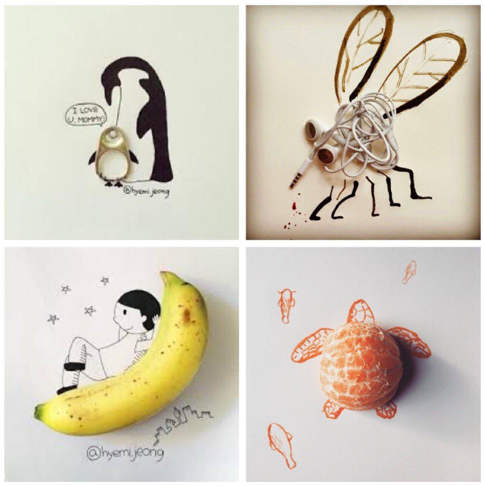
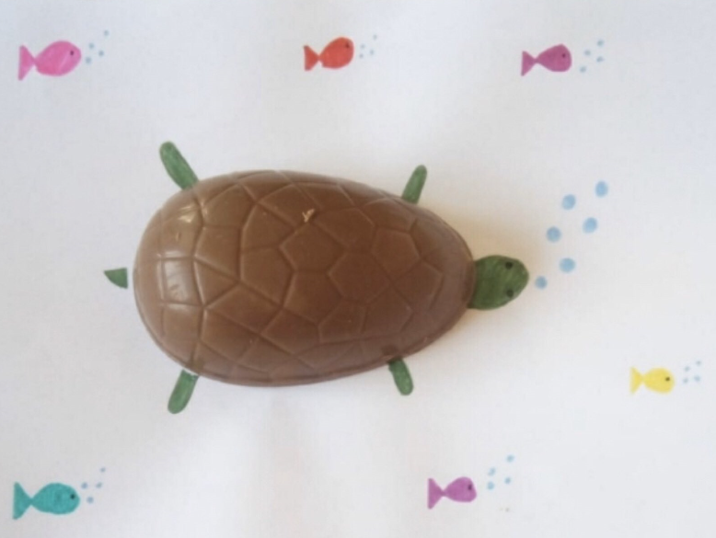
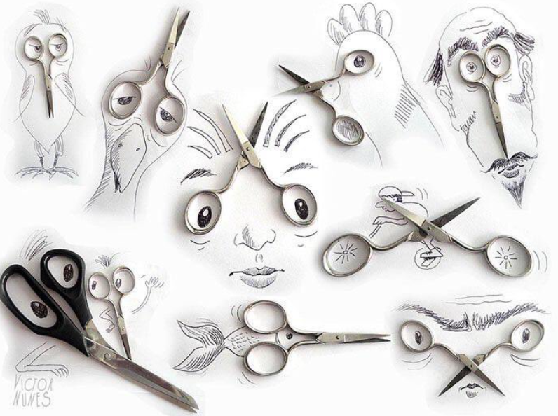

Paper 8: Maths

Solve the maths problems
- Crossing the River
A farmer is trying to cross a river. He is taking with him a rabbit, carrots and a fox and he has a small raft. He can only bring 1 item a time across the river because his raft can only fit either a rabbit, the carrots or the fox. How does he cross the river? (You can assume that nothing is eaten or escapes!)
3 marks
- You are driving a bus to St Barnabas. You drive through Hanham and pick 1 child up, you drive through Kingswood and pick 1 child up, you drive through Oldland Common and pick 5 children up, you drive through Cadbury Heath and pick 4 children up. You drive through Warmley and pick up 10 children. 6 children get off because they decide to walk the rest of the way. Before reaching school, you pick up 14 children from North Common. Who is the bus driver?
1 mark
- How many squares are in the picture?

3 marks

